**Lecture: Test Environment Setup**

We will deploy three servers that will be used in our Ansible course. Once deployed, we will create and exchange the user and SSH keys needed to facilitate communication during our course.

Create a user test of all three server

And create ssh key of all server on user test and copy all the key to the server

So we can communicate all the server without password via ssh

## Lecture: Download and Installation



YUM UPDATE REPOLIST

THN

YUM INSTALL ANSIBLE

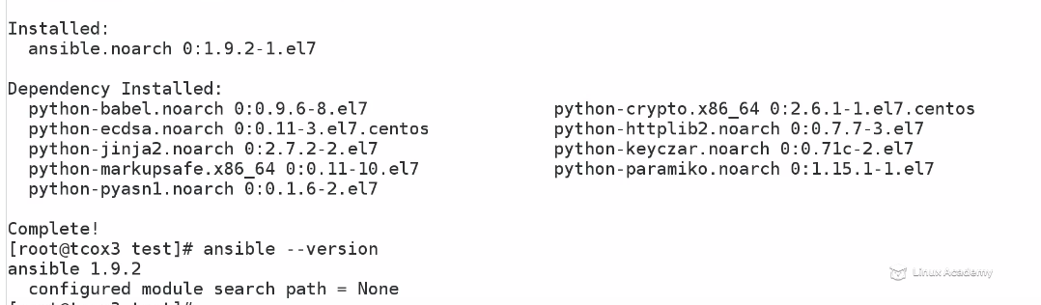

It is very simple we can refer to the get started course

## Lecture: Ansible Configuration File

This lesson will explore the various settings within the Ansible configuration file and how to set it up for our quick start.

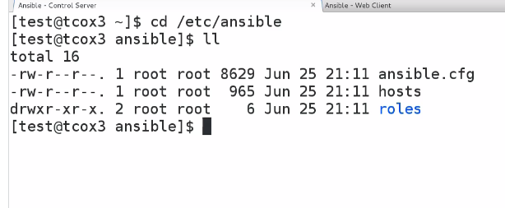

## Lecture: Ansible Python Dependencies

We will discuss how Ansible depends on Python and take a look at the various Python items installed as well as write a very short Python application to be sure everything is working as it should.

Pthon must be more 2.6

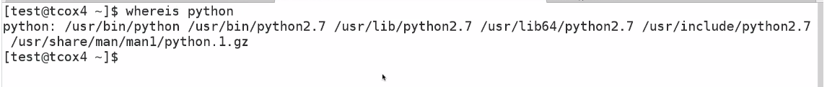

## Lecture: The HOSTS File

Unlike our system hosts file, the Ansible Hosts file lets us define groups that we can classify our various systems into, learn how to set up and then use the information in that file to interact with them.

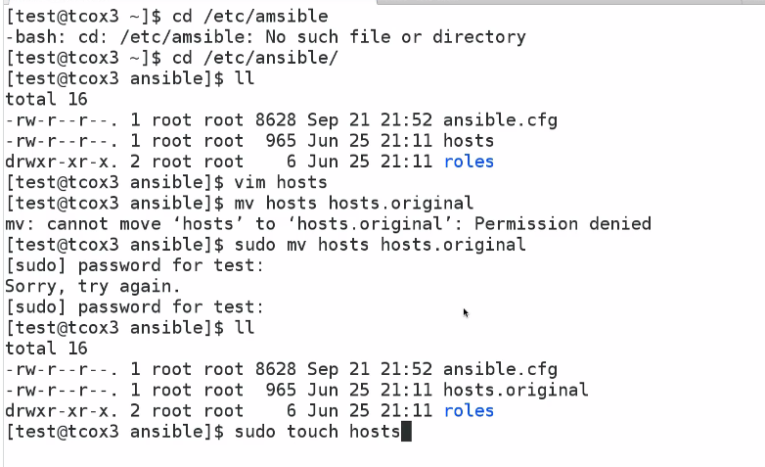

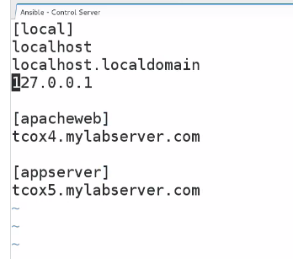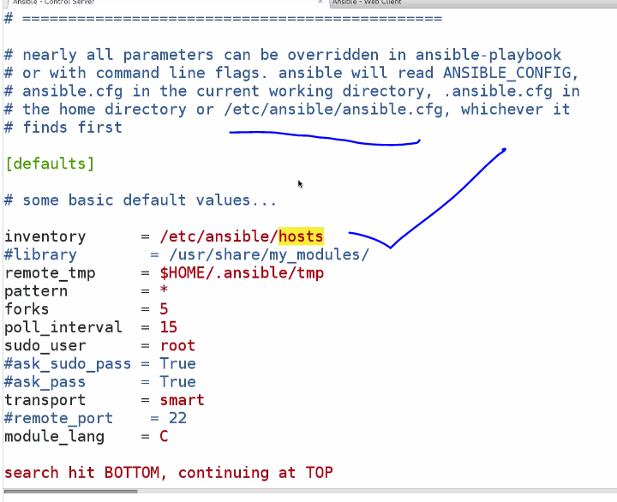

## Lecture: Overriding the Default HOSTS File

This lesson will explore the various settings within the Ansible configuration file and how to set it up for our quick start.

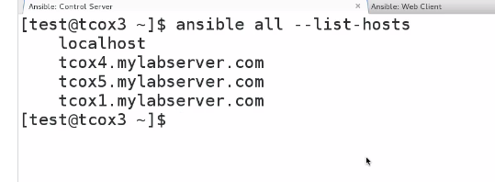

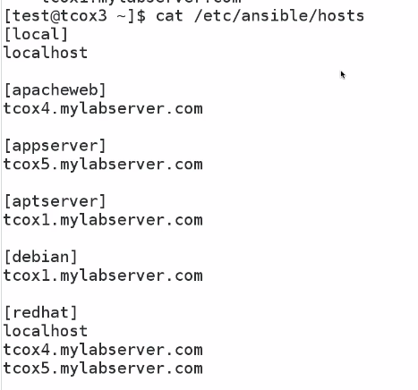

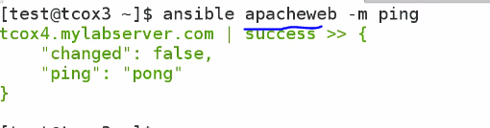

Can be group name or hostname

Overriding host file

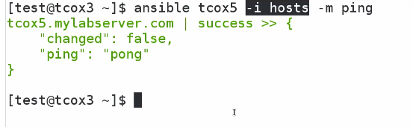

In that case we could tcox5 in not configured in /etc/ansible/hostfile

Using local host file created in that directory

## Lecture: Overriding the Default System Ansible.Cfg File

This lesson will explore the various settings within the Ansible configuration file and how to set it up for our quick start.

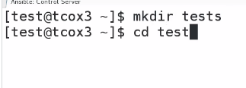

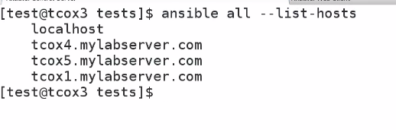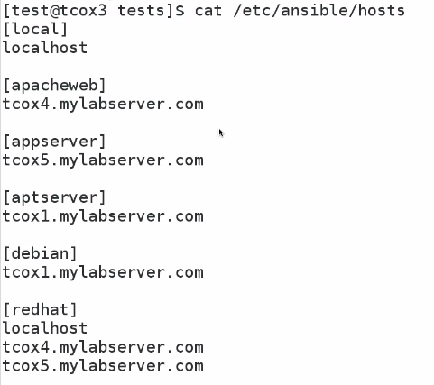

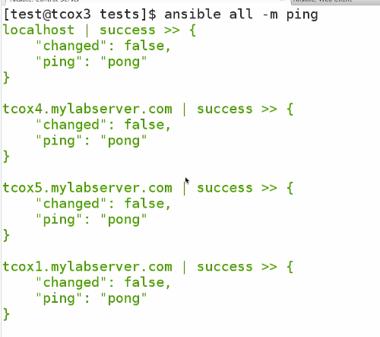

Suppose I m using ansible as unpriviledged user ,not able to change /etc/ansible/..



We gonna create hosts file in test directory

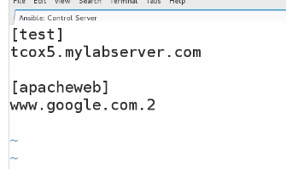

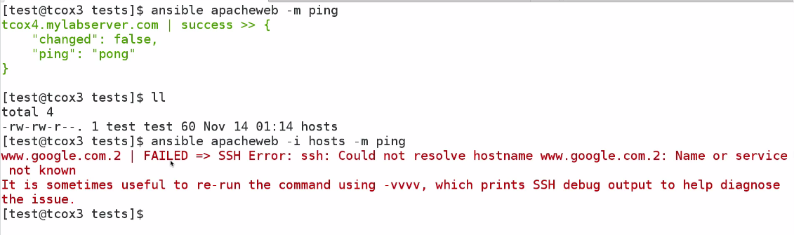

Could see by default it is not taking the host file created by us

What if we change the configuration file



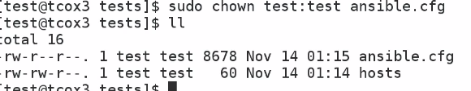

Now we gonna change the config file

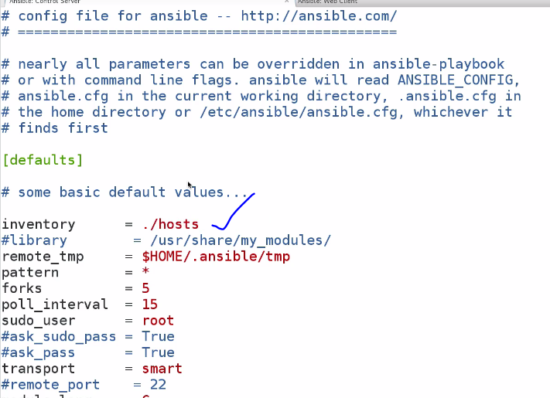

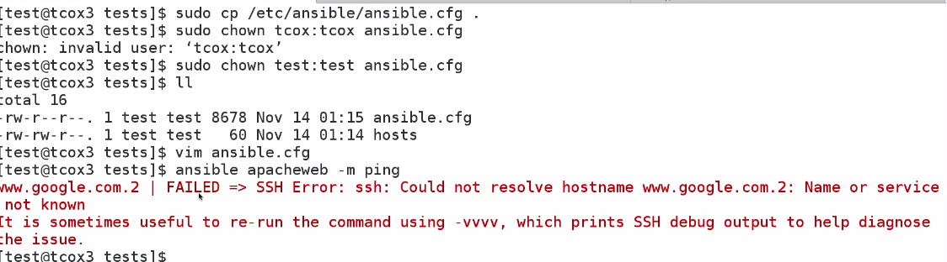

Now we are able to without -i

So that mean ansible look local directory for ansible configuration file . p-2

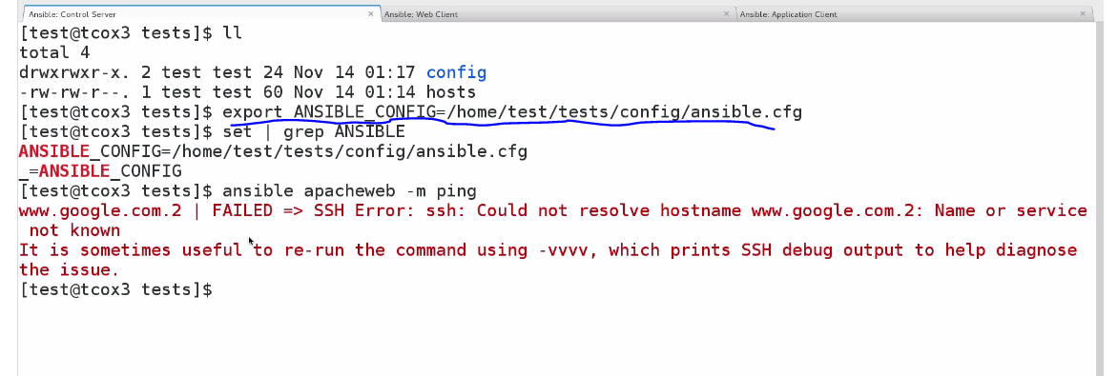

Firstplace ansible look for the configuration of we export it

1.it will check the currnt directory

2.it will check the local user home directory

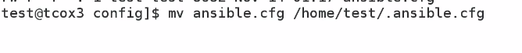

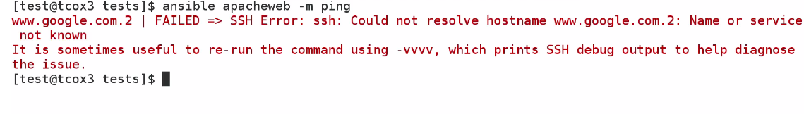

## Lecture: Overriding the Default Roles Path

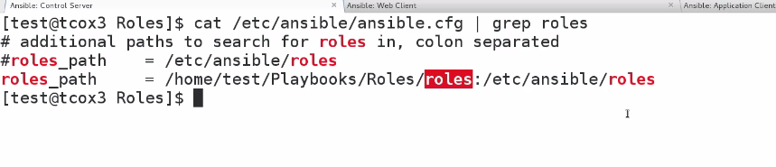

Defining alternative role path

3.export in system